Exercise section22

Mehrab Atighi

12/14/2021

Data = data.frame(  
 City = c("Atlanta" , "Boston" , "Chicago" ,  
 "Dallas" , "Denver" , "Detroit",  
 "Hartford" , "Honolulu" , "Houston",  
 "Kansas City" , "Los Angeles" ,  
 "New Orleans", "New York",  
 "Portland" , "Tucson" ,  
 "Washington"),  
 Murder = c(16.5,4.2,11.6,18.1,6.9,13.0,  
 2.5,3.6,16.8,10.8,9.7,10.3,  
 9.4,5.0,5.1,12.5),  
 Rape = c(24.8,13.3,24.7,34.2,41.5,35.7,  
 8.8,12.7,26.6,43.2,51.8,39.7,  
 19.4,23.0,22.9,27.6),  
 Robbery = c(106,122,340,184,173,477,  
 68,42,289,255,286,266,  
 522,157,85,524),  
 Assault = c(147,90,242,293,191,220,  
 103,28,186,226,355,283,  
 267,144,148,217),  
 Burglary = c(1112,982,808,1668,1534,  
 1566,1017,1457,1509,1494,  
 1902,1056,1674,1530,1206,  
 1496),  
 Larceny = c(905,669,609,901,1368,1183,  
 724,1102,787,955,1386,  
 1036,1392,1281,756,1003),  
 AutoThef = c(494,954,645,605,780,  
 788,468,637,697,765,862,  
 776,848,488,483,793))  
#a) is with hand writing the distance between Atlanta and Boston:  
  
#b)  
  
Dist1 = dist(Data[1:6,-1] , method = "euclidean",diag = TRUE , upper = TRUE)  
model1 = hclust(Dist1 , method = "single")  
model1

##   
## Call:  
## hclust(d = Dist1, method = "single")  
##   
## Cluster method : single   
## Distance : euclidean   
## Number of objects: 6

plot( model1 , hang = -1 )

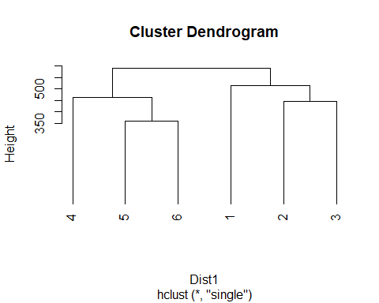

#c)  
  
Dist2 = dist(Data[,-1] , method = "euclidean",diag = TRUE , upper = TRUE)  
model2 = hclust(Dist2 , method = "single")  
model2

##   
## Call:  
## hclust(d = Dist2, method = "single")  
##   
## Cluster method : single   
## Distance : euclidean   
## Number of objects: 16

plot( model2 , hang = -1 )

